PRATEEK GIRISH GIRIRADDI
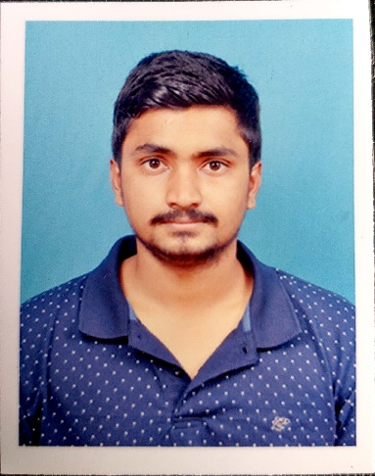
Email: prateekgg23@gmail.com
Contact number: 6362354841

Objective:
Seeking a challenging career with a progressive organization that provides an opportunity to capitalize my technical skills and abilities in the of information technology.

Education Qualification:
Course | Institute | University | Year of passing | Percentage of marks obtained/CGPA
BE in (Civil Engineering) | SDM College of Engineering &Technology | Autonomous College Under VTU, Belagavi | 2022(Pursuing) | 8.0
PUC | VIKAS Pre University Mangalore | Karnataka State Board | 2018 | 84.5%
SSLC | Parvathamma Shamanur Shivashankarappa English Medium Residential School, Tholahunse, Davangere | Central Board of Secondary Education | 2016 | 81%

Academic Projects:
- Minor Project Report on Intelligent Traffic Monitoring System
This project is aimed at Prioritize moderate traffic conditions by analyzing real-time traffic situations -That is,
-Providing congestion free traffic.
-Improvising traditional ticketing with automated E-Bill payment system.
-Speed sensors to warn commuters over speed violations.

- Extensive Survey

- Finding capacity of reservoir
- with using Contour Maps
- Highway Project
- Finding reduced level with using Profile levelling

Technical skills:

- Auto Cad
- HTML
- Basics of C language
- Excel sheets, Power bi
- Basic skills: MS Word ,MS Power Point & various means communication .

Hobbies:

State level Football player,
Swimmer.

Personal Details:

Father’s Name: Girish v Giriraddi
Mother’s Name: Padma
DOB: 23/09/2000
Languages known: English, Kannada, Hindi, (learning German)
Address: At – Yattinahalli,
Post- Gudagur,
Tal- Ranebennur,
Dist- Haveri,
Pin code- 581115.

Declaration:

I hereby declare that above information is true, correct to the best of my knowledge.

